REPORT ON

Activated Sludge Process

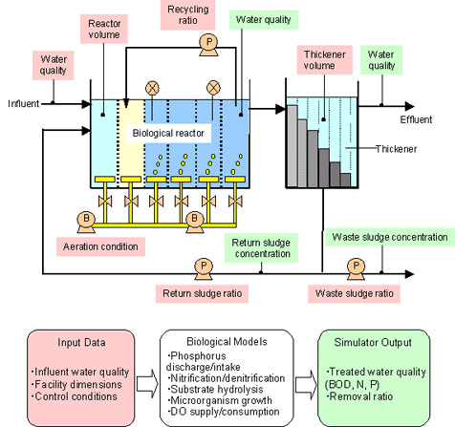

SUBMITTED TO: SUBMITTED BY:

PROF: K.S.BABU KANWARJOT SINGH
1040253

THAPAR UNIVERSITY
PATIALA-147004
PUNJAB

ACKNOWLEDGEMENT

I feel highly delighted with the way my article has complied and completed. It is a matter of pride for me that I worked for a very loving and caring institute who is totally devoted to develop the technical and human resource skills.

Any accomplishment requires the effort of many people and this work is no different. The recent industrial trip to Rajpura Water Treatment Plant and Patiala Distillery helped me in understanding and hereby presenting my report. I am indebted to my teacher MR K.S.BABU for guidance and organizing such a successful educational trip.

KANWARJOT SINGH
ROLL NO:1040253
CIVIL

Contents

- 1 Introduction
- 2 Purpose
- 3 History
- 4 General Principles
  - 4.1 Definitions
  - 4.2 Arrangement
- 5 Types of plants
  - 5.1 Package Plants
  - 5.2 Oxidation Ditch
  - 5.3 Deep ShaftTM
- 6 Aeration methods
  - 6.1 Diffused Aeration
  - 6.2 Surface aerators (Cones)
- 7 References
- 8 External links

Introduction
Activated sludge is a process in sewage treatment in which air or oxygen is forced into sewage liquor to develop a biological floc which reduces the organic content of the sewage. In all activated sludge plants, once the sewage has received sufficient treatment, excess mixed liquor is discharged into settling tanks and the supernatant is run off to undergo further treatment before discharge. Part of the settled material, the sludge, is returned to the head of the aeration system to re-seed the new sewage entering the tank. This fraction of the floc is called R.A.S - Return Activated Sludge. The remaining sludge, also called W.A.S - Waste Activated Sludge, is further treated prior to disposal. (W.A.S is also sometimes called S.A.S - Surplus Activated Sludge)
Activated sludge is also the name given to the active biological material produced by activated sludge plants and which affects all the purification processes. This material, which in healthy sludge is a brown floc, is largely composed off saprophytic bacteria but also has an important protozoan flora mainly composed of amoebae, Spirotrichs, Peritrichs including Vorticellids and a range of other filter feeding species. Other important constituents include motile and sedentary Rotifers. In poorly managed activated sludge, a range of mucilaginous filamentous bacteria can develop including Sphaerotilus natans which produces a sludge that is difficult to settle and can result in the sludge blanket decanting over the weirs in the settlement tank to severely contaminate the final effluent quality. This material is often described as sewage fungus but true fungal communities are relatively uncommon.

Purpose
In a sewage treatment plant, Activated Sludge process can be used for one or several of the following purpose:
- Oxidizing carbonaceous matter: biological matter
- Oxidizing nitrogenous matter: mainly ammonium and nitrogen in biological materials.
- removing phosphate
- driving off entrained gases carbon dioxide, ammonia, nitrogen etc.
- generating a biological floc that is easy to settle.
- generating a liquor low in dissolved or suspended material

History
The activated sludge process was discovered by accident in Britain in 1913. Experiments on treating sewage in a draw-and-fill reactor (the precursor to today's sequencing batch reactor) produced a highly treated effluent. Believing that the sludge had been activated (in a similar manner to activated carbon) the process was named activated sludge. Not until much later was it realised that what had actually had occurred was a means to concentrate biological organisms, decoupling the liquid retention time (ideally, low, for a compact treatment system) from the solids retention time (ideally, fairly high, for an effluent low in BOD₅ and ammonia.)

General Principles

Definitions
- Raw water = water entering the system
- Mixed liquor = the mix of raw water and activated sludge.
- Return activated sludge (R.A.S) = activated sludge extracted from the system and mixed with raw water to form the mixed liquor.
- Waste activated sludge (W.A.S.)/Surplus activated sludge (S.A.S.)= activated sludge in excess that is extracted from the system to be directed to sludge treatment.
- Sludge age = the average time biological sludge stay in the system. In simpler words, it can be defined as the average age of a bactery in the system.

Arrangement
The general arrangement of an activated sludge process for removing carbonaceous pollution includes the following items:
- Aeration tank where air (or oxygen) is injected in the mixed liquor.
- Settling tank (usually referred to as "final clarifier" or "secondary settling tank") to allow the biological flocs to settle, thus separating the biological sludge from the clear treated water.
This is illustrated in the following diagram:
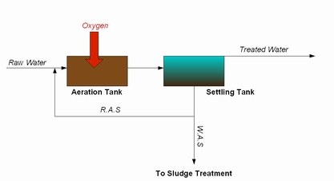
Treatment of nitrogenous matter or phosphate involve additional steps where the mixed liquor is left in anoxic condition (no residual dissolved oxygen).

Types of plants
There are a variety of types of activated sludge plants. These include :

Package Plants
There are a wide range of other types of plants, often serving small communities or industrial plants that may use hybrid treatment processes often involving the use of aerobic sludge to treat the incoming sewage. In such plants the primary settlement stage of treatment may be omitted. In these plants, a biotic floc is created which provides the required substrate.
Package plants are commonly variants of extended aeration, to promote the 'fit & forget' approach required for small communities without dedicated operational staff. There are various standards to assist with their design

Oxidation Ditch
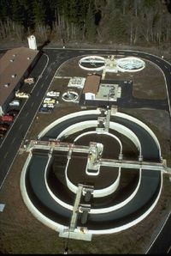
Oxidation Ditch at Pelican Bay State Prison in Northern California
In some areas where more land is available sewage is treated in large round or oval ditches with one or more horizontal aerators typically called brush or disc aerators which drive the mixed liquor around the ditch and provide aeration. These are oxidation ditches, often referred to by manufacturer's trade names such as Pasveer, Orbal, or Carrousel. They have the advantage that they are relatively easy to maintain and are resilient to shock loads that often occur in smaller communities (i.e at breakfast time and in the evening).
Oxidation ditches are installed commonly as 'fit & forget' technology, with typical design parameters of a hydraulic retention time of 24 - 48 hours, and a sludge age of 12 - 20 days. This compares with nitrifying activated sludge plants having a retention time of 8 hours, and a sludge age of 8 - 12 days.

Deep Shaft
Where land is in short supply sewage may be treated by injection of oxygen into a pressured return sludge stream which is injected into the base of a deep columnar tank buried in the ground. Such shafts may be up to 100 metres deep and are filled with sewage liquor. As the sewage rises the oxygen forced into solution by the pressure at the base of the shaft breaks out as molecular oxygen providing a highly efficient source of oxygen for the activated sludge biota. The rising oxygen and injected return sludge provide the physical mechanism for mixing of the sewage and sludge. Mixed sludge and sewage is decanted at the surface and separated into supernatant and sludge components. The efficiency of deep shaft treatment can be high.
Surface aerators are commonly quoted as having an aeration efficiency of 0.5 - 1.5 kg O₂/kWh, diffused aeration as 1.5 - 2.5 kg O₂/KWh. Deep Shaft claims 5 - 8 kg O₂/kWh.
However, the costs of construction are high. Deep Shaft has seen greatest uptake in Japan, because of the land area issues. Deep Shaft was developed by ICI, as a spin-off from their Pruteen process. In the UK it is found at three sites: Tilbury, Anglian water, treating a wastewater with a high industrial contribution; Southport, United Utilities, because of land space issues; and Billingham, ICI, again treating industrial effluent, and built (after the Tilbury shafts) by ICI to help the agent sell more.
DeepShaft is a patented, licenced, process. The licencee has changed several times, but is currently (2007) Kvaerner

Aeration methods

Diffused Aeration
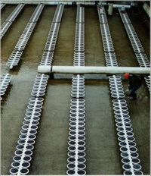
Fine bubble membrane diffusers in an aeration tank
Sewage liquor is run into deep tanks with diffuser blocks attached to the floor. These are like the diffuser blocks used in tropical fish tanks but on a much larger scale. Air is pumped through the blocks and the curtain of bubbles formed both oxygenates the liquor and also provide the necessary stirring action. Where capacity is limited or the sewage is unusually strong or difficult to treat, oxygen may be used instead of air.

Surface aerators (Cones)
Vertically mounted tubes of up to 1 metre diameter extend from just above the base of a deep concrete tank to just below the surface of the sewage liquor. A typical shaft might be 10Metres high. At the surface end the tube is formed into a cone with helical vanes attached to the inner surface. When the tube is rotated, the vanes spin liquor up and out of the cones drawing new sewage liquor from the base of the tank. In many works each cone is located in a separate cell that can be isolated from the remaining cells if required for maintenance. Some works may have two cones to a cell and some large works may have 4 cones per cell.

References
- http://www.britishwater.co.uk/COP_Flows___Loads_2_-_final_-_6_page_version-22Jun05.pdf
- http://products.ihs.com/cis/Doc.aspx?AuthCode=&DocNum=252510
- British Standard
- Tilbury construction
- Aker Kvaerner wastewater

External links
- Steady-state activated sludge model
- Various PhD theses on modelling activated sludge systems
- Detailed algorithms for ASM1 and Takacs settling tank model
- Metabolic activated sludge model

